Kickstarter Analysis

**Overview of project:**

The purpose of the project was to analyze Kickstarter funding data to assist Louise with her own Kickstarter campaign so that it has a higher chance of reaching it’s funding goal.

**Analysis & Challenges:**

In order to help Louise, we focused the analysis on campaign launch dates and campaign funding goals to better understand how these variables affect outcomes. When analyzing the launch date variable, we filtered the data by “theater” campaigns and organized the outcomes according to what month during the year in which they were launched. When analyzing the campaign funding goal variable, we filtered the data further by “play” campaigns and sorted the outcome percentages based on their funding goal ranges.

The challenge with this analysis was making sure the data for the charts was accurate. One of the errors I encountered was not including “=” in my countifs formulas so I was not capturing all of the data.

**Results:**

According to the “Theater outcomes based on launch date” data, theater campaigns have a higher chance of being successful during May to July approximately. Interestingly, the number of failed campaigns seems fairly steady throughout the year which may indicate that campaigns fail for other reasons than their launch date such as funding goals.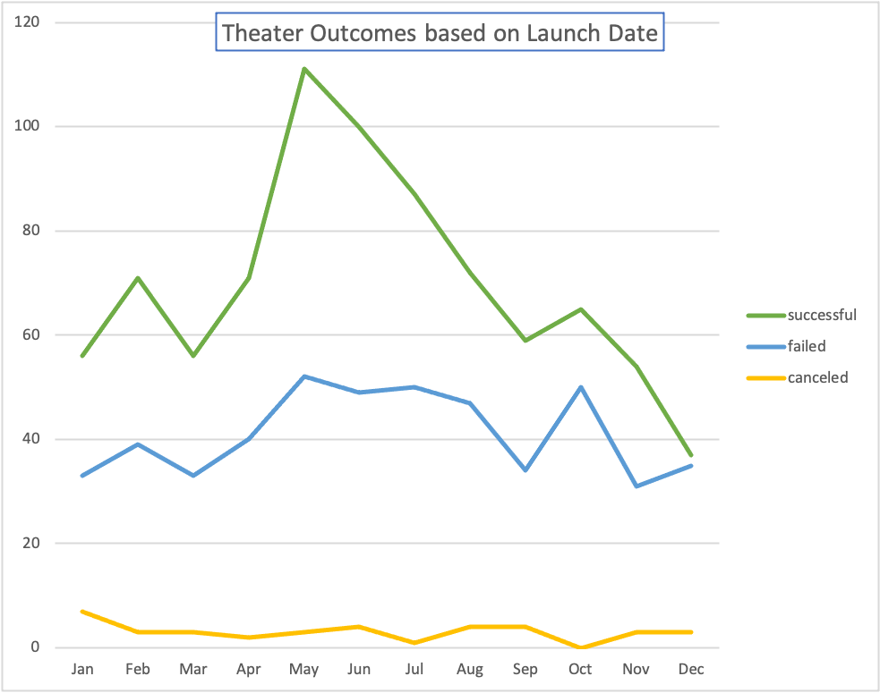

According to the “Outcomes based on goal” data, plays generally have a higher chance the lower their respective funding goals. For the most part, as funding goals increased, their chances of success decreased. 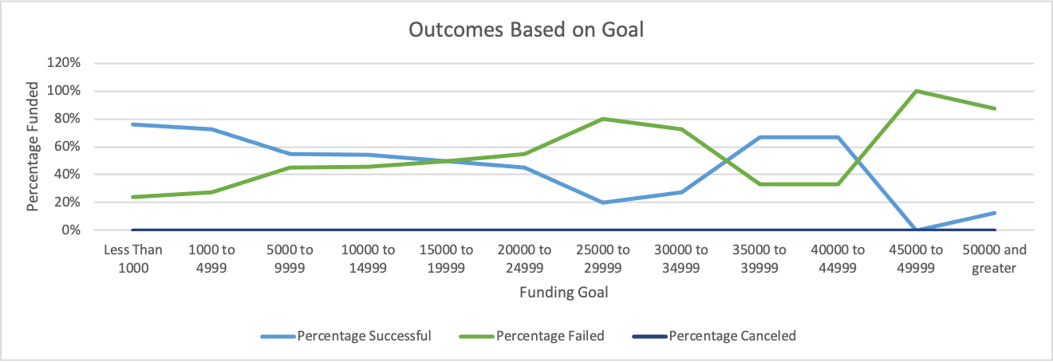

If Louise wants to have the best chance of having a successfully funded Kickstarter campaign, she should strongly consider launching her campaign from May to July and keeping her funding goal to a minimum.

One of the major limitations with the dataset was the actual amount of data itself. It would have been nice to have more data points to analyze which would’ve resulted in more accurate results.

Another graph that would’ve been worth creating would be one similar to “Theater outcomes based on launch date” but it focus on the subcategory of plays only. It would be interesting to see how the results compare and what differences there may be.